1. Most 50% = Poor planning | constraint = A Constraint | least 50% = An assumption

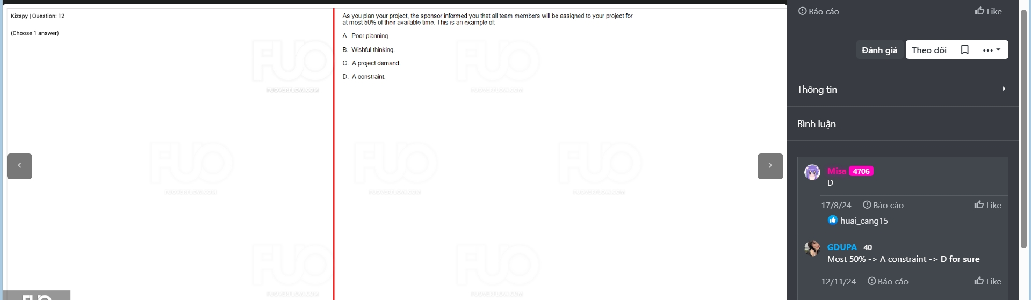

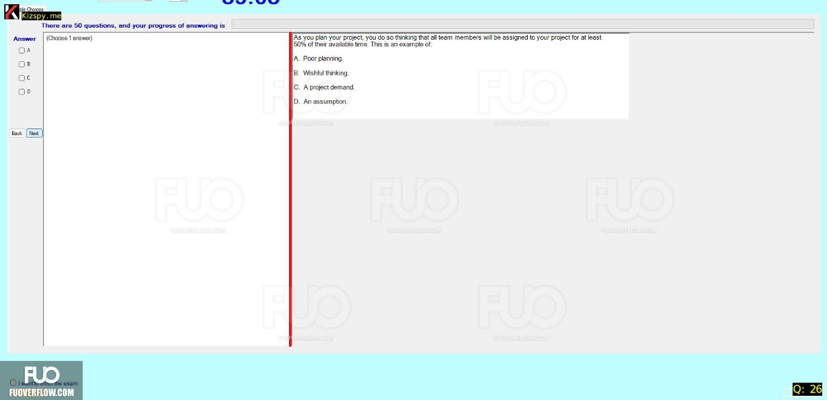

2. EF= early start | LF = late start | LS = late finish

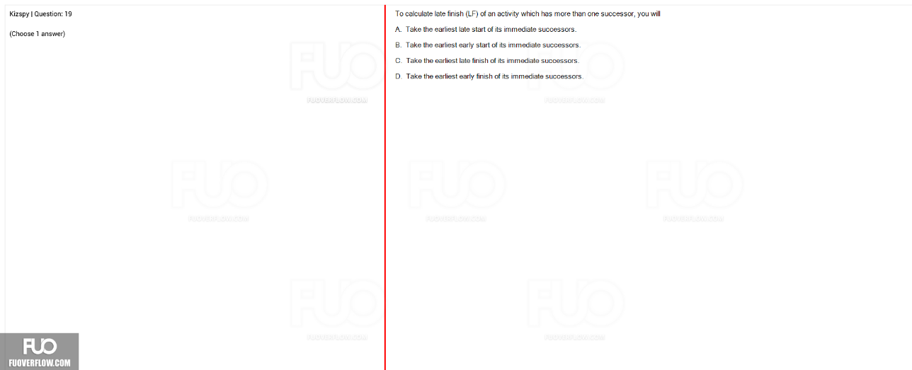

3.top-down= Costly to create | bottom-up= Less accurate  
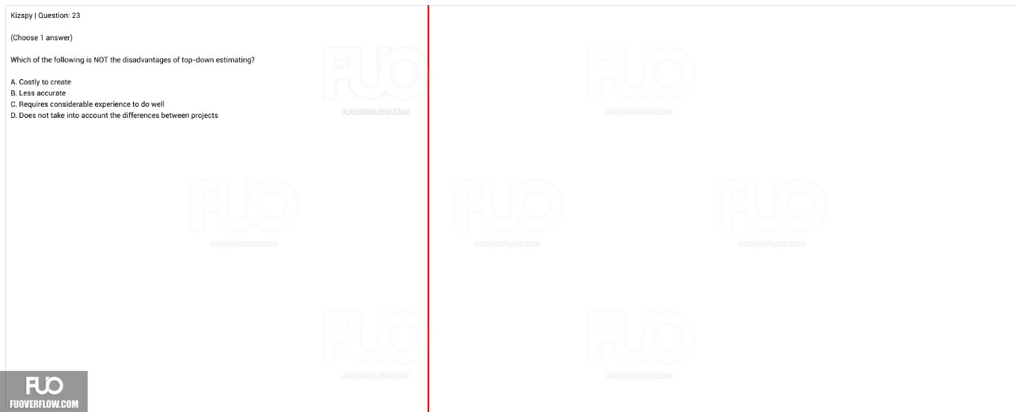

4. mitigate= probability | transfer = party

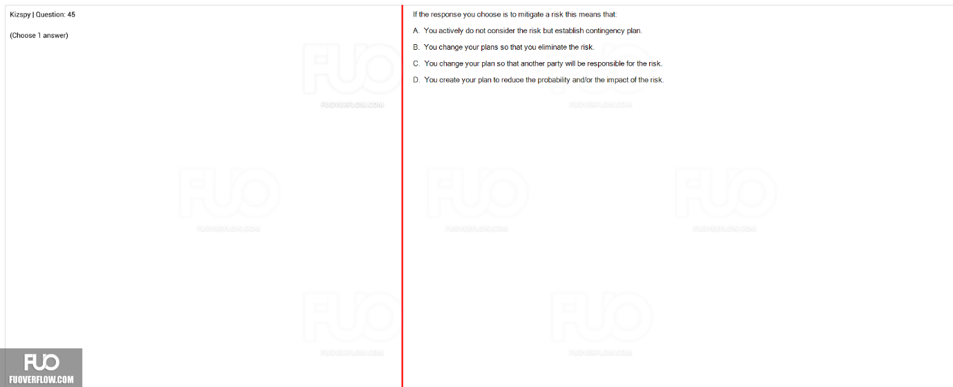

5. low …/ low… = Monitor | low …/ high = Keep satisfied

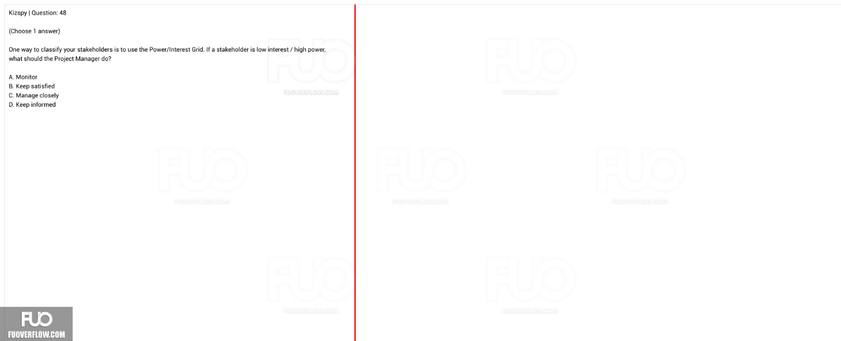

6. ….,and he …. = Supportive | ….,and actively …. = Leading

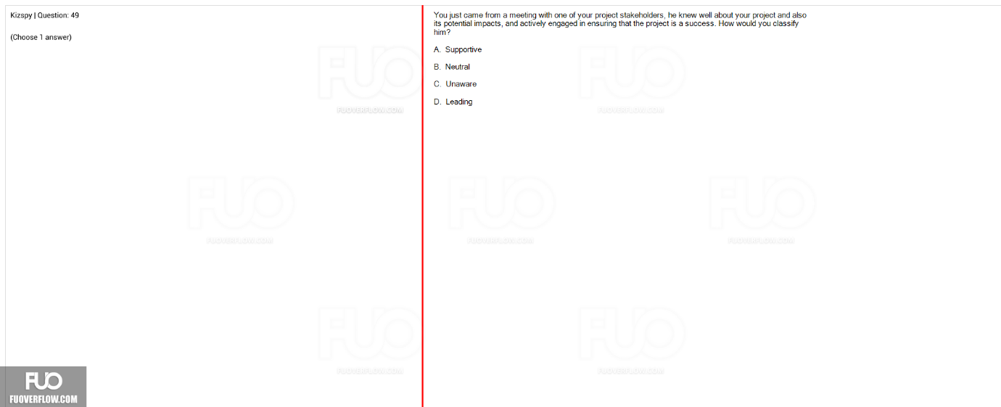

7…..  
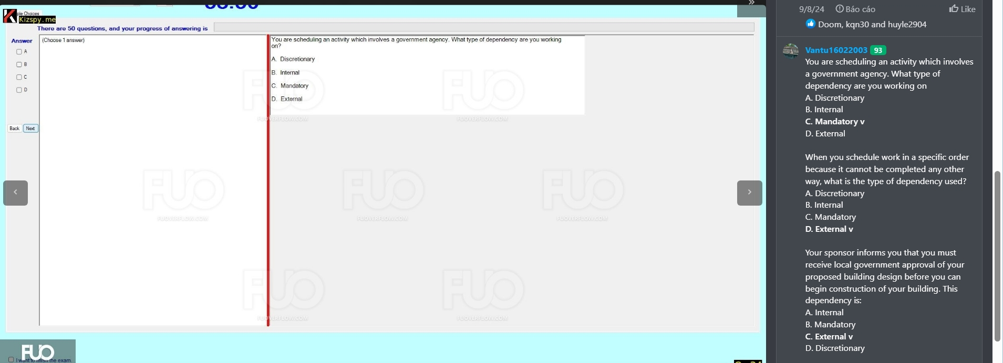

8.contingency reseve =tied to specific word | management reserve =not tied to specific word  
